]\\\\\\\\\\\\\\\\\\\\\\\\\\\\\\\\\\\\\\\\\\\\\\\\\\\\\\\\\\\\\\\\\\\\\\\\\\\\\\\\\\\\\W1-S2 GROUP REFLECTION
Design Principles
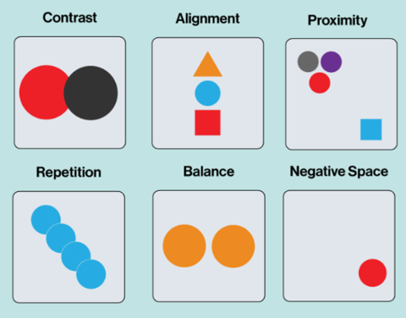

For this session: Make groups of 3 students.

 | Group work (60 min)

You need to need to analyze 3 graphical designs (choose among the ones bellow)
- Complete the evaluation table for each analysis
- Propose improvements if needed (just ideas. You don’t have to draw anything)

 | Group presentations (15 min)

It’s time to share you group work to the whole class

- 1 speaker per group
- Speakers are randomly selected to present each group work activity

WORK 1
Which design you choose? (letter): __A_

CATEGORY | CRITERIA | YOUR ANLAYSIS
CONTRAST | - Does the design use enough contrast to differentiate elements?  - Do the elements with high contrast stand out as intended? | No, it doesn’t.High-contrast elements like “CADT RESTAURANT” do stand out; however, I suggest applying similar high-contrast styling to the “Breakfast” and “Lunch” .
ALIGNMENT | - Are text, images, and other elements aligned properly to create order and cohesiveness?  - Are there any elements that feel "out of place"? | Yes, maybe it is.The alignment of the design isn’t fully effective; consider using different alignments for the headings and body .
PROXIMITY | - Are headlines, body text, and images that belong together placed near each other?  - Are elements spaced too far apart or too close together? | Yes, related elements (like “Breakfast” and its menu items) are placed near each other.the spacing between sections is too tight between the headers and content.
REPETITION | - Are colors, fonts, or shapes used consistently across the design?  - Does the repetition feel intentional and effective? | No, the text and font are similar from header to body. I would recommend use distinct colors. So, the key elements don’t blend with surrounding content
WHITE SPACE | - Does the design have enough white space to avoid overcrowding, or does it feel empty?  - Is the white space used to guide the viewer's eye effectively? | No, it doesn’t.Adding more spacing around sections and margins would make the menu easier to read and guide the viewer’s eye more effectively
BALANCE | - Is the design the same on both sides or does one side have more weight than the other?  - Does the design feel even and comfortable to look at, or does it feel lopsided and uneven? | No, the layout isn’t visually balanced; the text block sits mostly on the left side, leaving empty space on the right. centering the text box or redistributing elements would be the solution
IMPROVEMENTS | - Write your improvement proposition (If any)

WORK 2
Which design you choose? (letter): E
CATEGORY | CRITERIA | YOUR ANALYSIS
CONTRAST | - Does the design use enough contrast to differentiate elements?  - Do the elements with high contrast stand out as intended? | Yes, the design uses a lot of vibrant colors that makes a lot of elements stand out.  However, there are too many high-contrast elements on the screen, which make the design feel overwhelming and distracting for the audience.
ALIGNMENT | - Are text, images, and other elements aligned properly to create order and cohesiveness?  - Are there any elements that feel "out of place"? | Some images are properly aligned, which help create structure. However, when different group of images are aligned together it makes them seems of out place
PROXIMITY | - Are headlines, body text, and images that belong together placed near each other?  - Are elements spaced too far apart or too close together? | The headline, body text, and image are designed very well within each section. But when all the sections group together making it overlap each other making it unreadable.
REPETITION | - Are colors, fonts, or shapes used consistently across the design?  - Does the repetition feel intentional and effective? | The design uses green and yellow consistently throughout, which helps create a strong and recognizable brand identity. The repetition of these colors feels intentional and effective.
WHITE SPACE | - Does the design have enough white space to avoid overcrowding, or does it feel empty?  - Is the white space used to guide the viewer's eye effectively? | There is not much white space in the design. All the vibrant colors are everywhere making it hard to look at and overwhelming.
BALANCE | - Is the design the same on both sides or does one side have more weight than the other?  - Does the design feel even and comfortable to look at, or does it feel lopsided and uneven? | The design feels unbalanced. There are more images on the right side, making it feel heavier but the bright yellow color on the left side attracts my eyes and helps draw attention.
IMPROVEMENTS | - Write your improvement proposition (If any)
WORK 3
Which design do you choose? (letter): H

CATEGORY | CRITERIA | YOUR ANALYSIS
CONTRAST | - Does the design use enough contrast to differentiate elements?  - Do the elements with high contrast stand out as intended? | Yes, the design uses a good amount of contrast, which helps separate the elements, making the design looks clean while also making the important part stand out.
ALIGNMENT | - Are text, images, and other elements aligned properly to create order and cohesiveness?  - Are there any elements that feel "out of place"? | The overall alignment in this design is clean and looks professional. The left-alignment of all text creates an organized structure that is easy to read and follow.
PROXIMITY | - Are headlines, body text, and images that belong together placed near each other?  - Are elements spaced too far apart or too close together? | The headlines, body text are well-placed together, guiding the viewer’s attention. The space/ empty areas between elements gives breathing room, improves readability.
REPETITION | - Are colors, fonts, or shapes used consistently across the design?  - Does the repetition feel intentional and effective? | In this design, the repetition use of the color red and different font makes the layout feel polished and purposeful.
WHITE SPACE | - Does the design have enough white space to avoid overcrowding, or does it feel empty?  - Is the white space used to guide the viewer's eye effectively? | White space did a pretty good job in this design because the usage of white space isn’t overcrowding,which makes it clean and easy to digest.
BALANCE | - Is the design the same on both sides or does one side have more weight than the other?  - Does the design feel even and comfortable to look at, or does it feel lopsided and uneven? | The design is well-balanced and eye-catching. The combination of text and image creates clear, engaging design, while image draws attention the text delivers context.
IMPROVEMENTS | - Write your improvement proposition (If any)

DESIGN A
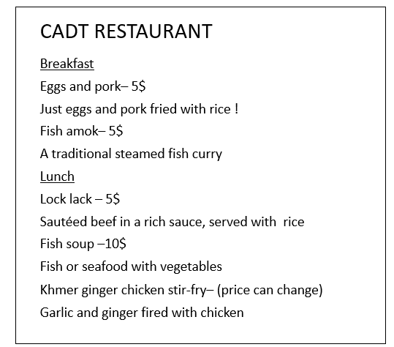

DESIGN B
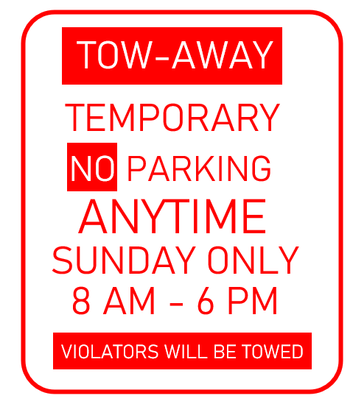

DESIGN C

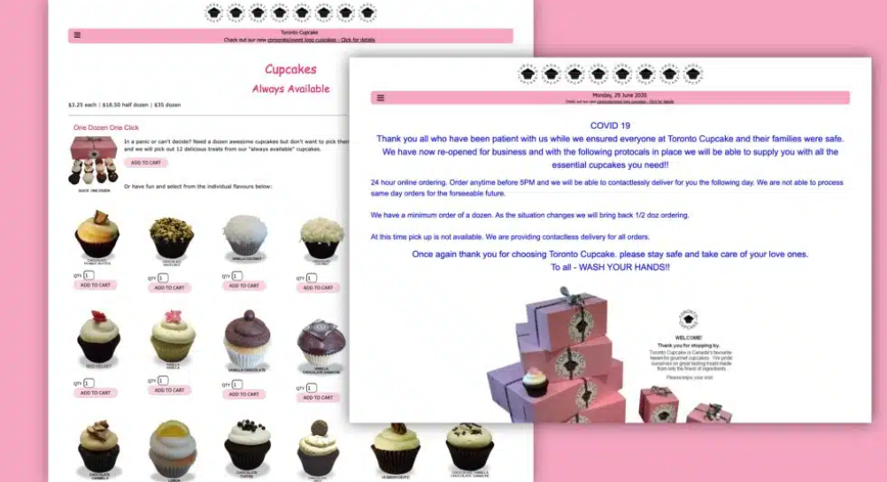

DESIGN D

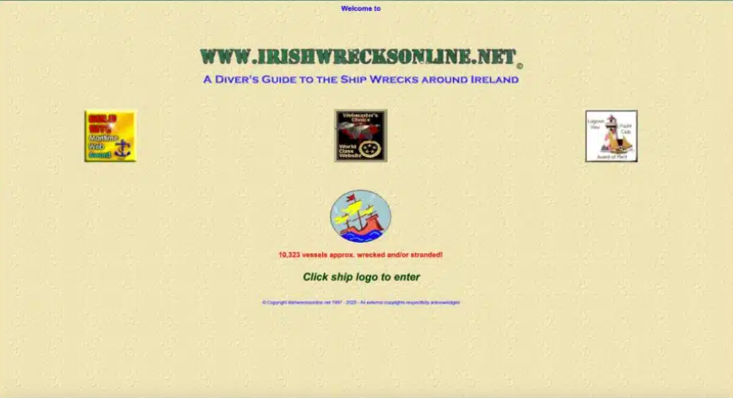

DESIGN E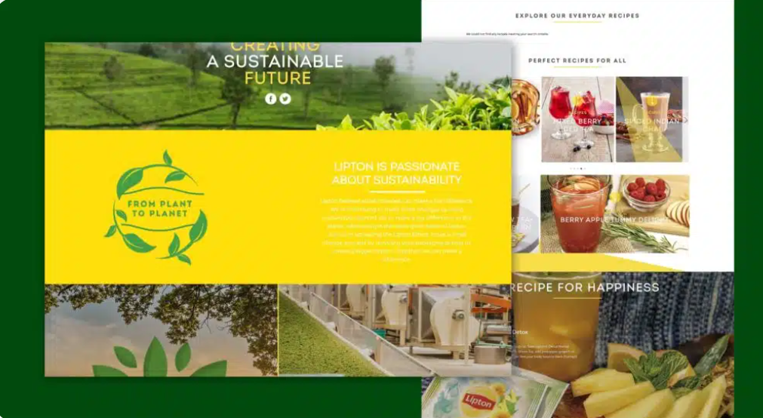

DESIGN F

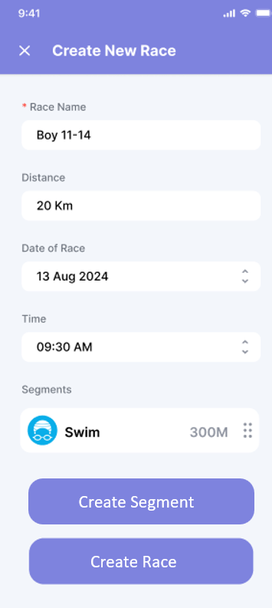

DESIGN G

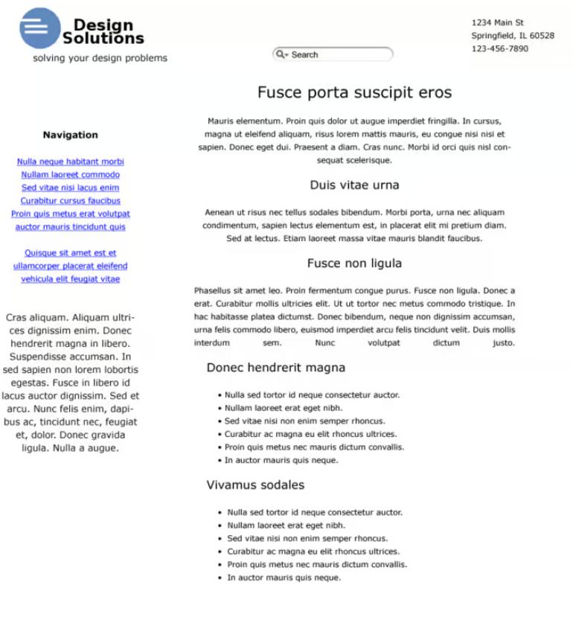

DESIGN H

